**COMP 3122 – Assignment 01 (Individual Assignment)**

**Goal:** Working with CSV files and applying NumPy functions

**Due:** Please check the announcement and the submission folder

Please, write your name and relevant info in the first cell(s) as follow:

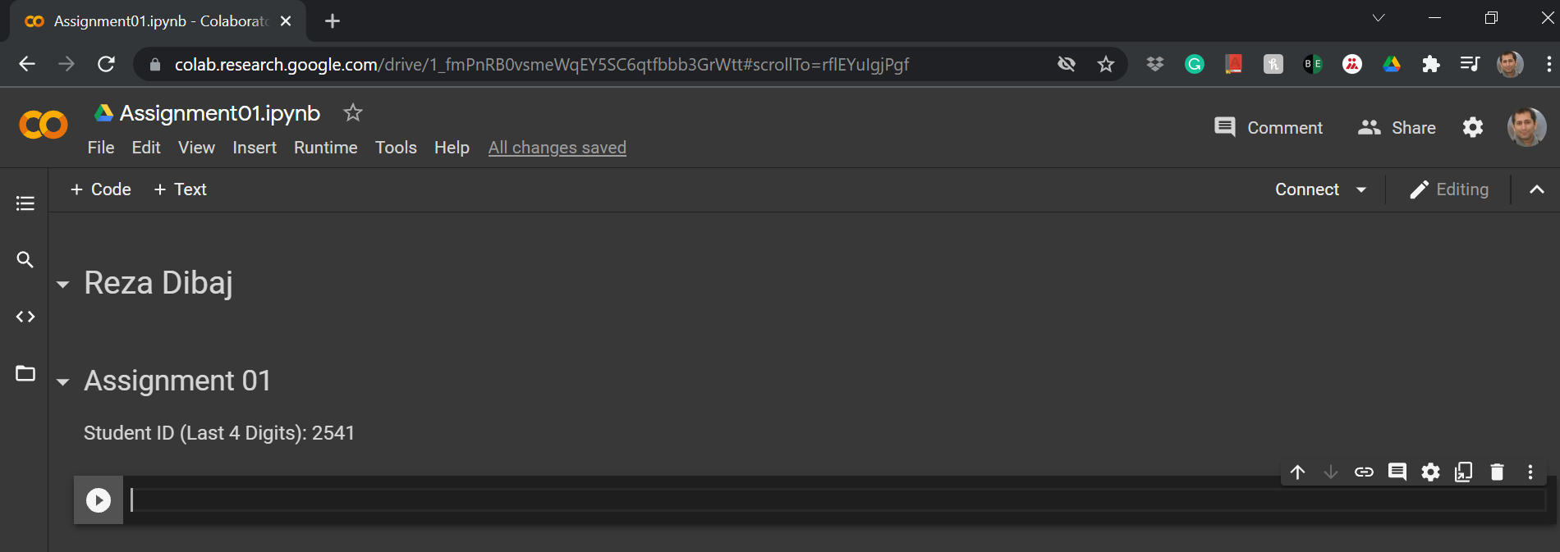

1. Import the **biostats.csv** file, and place it in an appropriate dataset. (0.5 point)
2. Fetch the **Age** column of the dataset as an array, and use a variable to hold it. (0.5 point)
3. Print the content of the **Age**column. (0.5 point)
4. Calculate the average, standard deviation, minimum and maximum of the array, and print the result. (0.5 point)
5. Find the 30th percentile, median, and 70th percentile of the **Age** column. (0.5 point)
6. Using the Matplotlib library, please draw a histogram chart for the **Age** column. Please, use an appropriate title, X-label, and Y-label. Moreover, include your first name in the title, e.g. **Age Distribution – By Reza** (0.5 point)

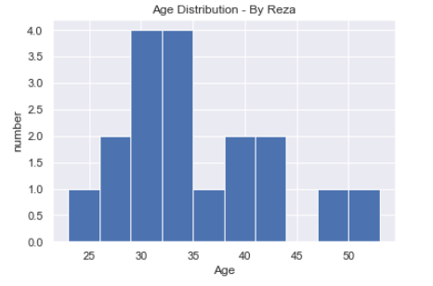

# **Deliverables:**

* **Assignment01. ipynb (3 Marks)**
* **A link to your uploaded to YouTube (3 Marks)**

**Please upload your .pynb file (Write Submission), and enter your YouTube link in the Text Submission section (see the following image.)**

The uploaded video needs to be (almost 5-minute) explanation of what you have done and learned in this assignment.

The quality of the video is not important, so please upload your first attempt.

# **Important:**

**Submissions without video explanations would receive no mark.**

Thank you, and good luck,

Coach Reza